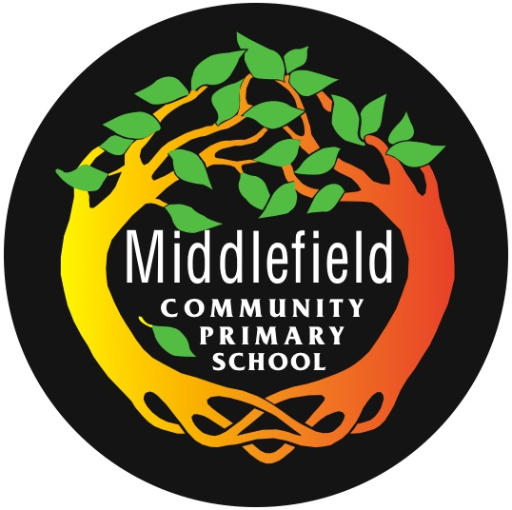
Middlefield Community Primary School

Curriculum Intent:
At Middlefield we believe that knowledge and skill are intertwined and our curriculum focuses on ensuring that pupils can achieve both. Through this development of knowledge and skills we ensure progression and depth of learning.

Where possible, cross-curricular links are made as we believe this makes our curriculum relevant and meaningful to pupils and puts knowledge into context. This is best demonstrated through the ‘Opening World’s’ humanities curriculum.

We deliver a vocabulary rich curriculum and pupils are provided with subject-specific vocabulary and knowledge that allows them to build links and enhance their learning across other subjects. Ensuring our pupils have a broad vocabulary is a priority at Middlefield.

Curriculum Implementation:
We deliver this by:
- Ensuring the learning environment is of high quality and promotes independent learning;
- Ensuring a broad and balanced curriculum – celebrating all subjects;
- Ensuring progression by building on what children know through the use of assessment;
- Bringing learning to life through a variety of enrichment activities e.g. well-planned regular trips, events and high quality resources; (see Middlefield Enrichment Map)
- Involving parents / carers in a series of regular school events such as Family Maths Events, Family Reading Events, Musical / Drama Performances;
- Involving parents/carers in learning;
Our School Values of Kindness, Determination, Empathy, Ambition, Positivity and Resilience permeate through all aspects of school life. British Values are strongly promoted through our SMSC provision, making sure that the fundamentals are taught: democracy, the rule of law, individual liberty, mutual respect for and tolerance of those with different faiths and beliefs and for those without faith.
Children are supported in their thinking, reasoning and questioning, whilst facilitating open dialogue, through Philosophy for Children (P4C). They are provided with opportunities to practice being; Caring, Collaborative, Critical and Creative which helps to develop deeper thinking skills, improve communication and teaches them the importance of and how to co-operate with each other.

Planning:
At each stage of the planning process, staff work closely together to create and develop a curriculum that meets the needs of the pupils at Middlefield, enabling all to receive a broad and balanced curriculum. We believe that our curriculum design is sustainable as all subject leads and teachers have an input and contribute to decision making.

Subject Leaders:
At Middlefield, in order to share expertise and domain specific knowledge across the school, teachers are ‘Subject Leaders’ for subjects in which they have a specialism or expressed a keen interest.

Core Subjects
English | Maths | Phonics | Science
Mr Fewtrell | Mr Lymath | Mrs Beresford | Mrs C. Smith

Foundation Subjects
Art &  Design | Computing | Design & Technology | Languages
Miss Emmott | Miss Foulkes | Miss Emmott/  Mrs Price | Mrs Donald/ Miss Welsh
Geography | History | Music | PE
Mrs E.J Smith | Miss Lyons | Mrs Warner | Mrs Crone

Other required curriculum subjects
RE | PSHE
Mrs Ellis | Mrs Evans/ Miss Morgan

Foundation Stage:
Our Foundation Stage Curriculum is guided by the EYFS guidelines and principles.

Curriculum Impact:
We believe that regular curriculum review and renewal is essential. Time is set aside for Subject Leaders to meet regularly with the Foundation Subject lead and SLT, to discuss and evaluate their specific subject area and ensure a shared vision and approach.

Core Subjects are assessed using NFER testing and informed teacher judgements. Information captured from assessment is used not only to identify gaps in pupil’s knowledge, skills and understanding but also to inform and improve on future curriculum design. The Head teacher subsequently produces a termly report showing attainment and progress of individuals and groups.

All assessment data, including foundation subjects is available electronically and is split into year groups and individual class teachers for easy reference for all stakeholders.

The Foundation Subject Leaders work collaboratively to design the Middlefield Curriculum Progression Grids, which are used to ensure that there is clear progression across year groups and key stages, through the national curriculum.

Subject Leaders are responsible for the organisation of subject - specific vocabulary in their curriculum area, deciding which words are essential and which are not. They will also have considered when the words will be first introduced and when they may be revisited.

Along with SLT, Subject Leaders are responsible for monitoring their particular subject to ensure that it is implemented consistently and effectively in line with agreed policies.

School Governors
An annual Curriculum Report is presented to the Governing Body during the school year, focusing on curriculum priorities identified in the School Development Plan.

The Curriculum Sub-Committee meet at least once per term to discuss curriculum priorities, achievements and next steps.

